Previous work
Previous work
- Thinking to write a paper on Faithfulness Gating for LLM knowledge Graph Construction
- About the paper
  - Introduces a source conditioned faithfulness gate
  - Improves accuracy of knowledge graph construction
  - LLMs often hallucinate so source conditioned NLI cross encoder was developed to score and prune
  - New benchmark and taxonomy was created
  - Conditioning the model on source text is the most critical factor for performance
  - Outperforming larger source blind judges
  - Nearly perfect result on synthetic data
  - Human labelled pilot revealed performance gap
  - Jist - this small and efficient model offers a cost effective way to ensure extracted data remains grounded in its original text

16 June 2026
16 June 2026
- Downloaded All the knowledge graph papers which I found from AAAI website of years 2025 and 2026.
- All papers majorly revolved around 8 sub topics:
  - Graph RAG/KGQA retrieval - FastToG, ProgRAG, LightPROF, AMAR, CogGRAG, SAR, MAB-RAG, DCTR, EPERM
  - Uncertainty/factuality - UAG, ARoG, TruthfulRAG, KEDKG
  - Inductive KGC - TARGI, S2DN, CBLiP, Rule-Guided GNN, CATS
  - Temporal KGs - 5EL, LLM-DR, DPCL-Diff
  - Multimodal/mixed-curvature KGC - MCKGC, APKGC, DOGE
  - Embedding/scoring objectives - KGCRR, RAA-KGC, SPAC
  - RL/logic-based - FULORA, LACT, SEmPI
  - Applied/off-axis - Vehicle re-ID, medical NLE, 3D assembly, autonomous driving, steganalysis, LLM unlearning
- Thought to continue with GraphRAG retrieval but noticed majority papers were of similar architecture, they used beam search or similar traversal improvements

17 June 2026
17 June 2026
- Thought to continue with Knowledge graph construction (link prediction style)
  - There are 3 paper related to this
    - KGCRR
      - Novelty - Framework design
      - Reciprocal Rank evaluation metric
      - Inconsistency between standard loss function like Log-likelihood
      - Developed CRR, plug and play objective function
      - Parameter pressure variable
      - Non linear transformation
      - Avoids common gradient vanishing issues
      - Integrating CRR leads to average improvement of 19.06%
      - Jist - Provides stable and effective approach to predict missing links within complex informational networks
    - CBLiP
      - Novel - Transformer based model design
      - Inductive setting - entities are unseen during training
      - To improve efficiency - replaces path encoding modules with connection biased attention mechanism and entity roles embeddings
      - Allows model to capture vital structural information and relative distances with the use of subgraphs without the need of manual path extraction
      - CBLiP is highly competitive with SOTA models
      - Jist - context aware attention can effectively mimic complex logical reasoning
    - RAA-KGC
      - Novelty - framework design
      - Leverage textual description of relation aware entities
      - Text based models struggle with link prediction because they lack contextual information regarding tail entity
      - By selection anchor entities from neighbour of head entity, the system generates more discriminative embeddings through a contrastive learning approach
      - Refine its ability to distinguish between candidate entities
      - Anchor enhancement strategy outperforms SOTA
      - Highly compatible so can be integrated in triple based and text based algorithms

18 June 2026
18 June 2026
- KGCRR
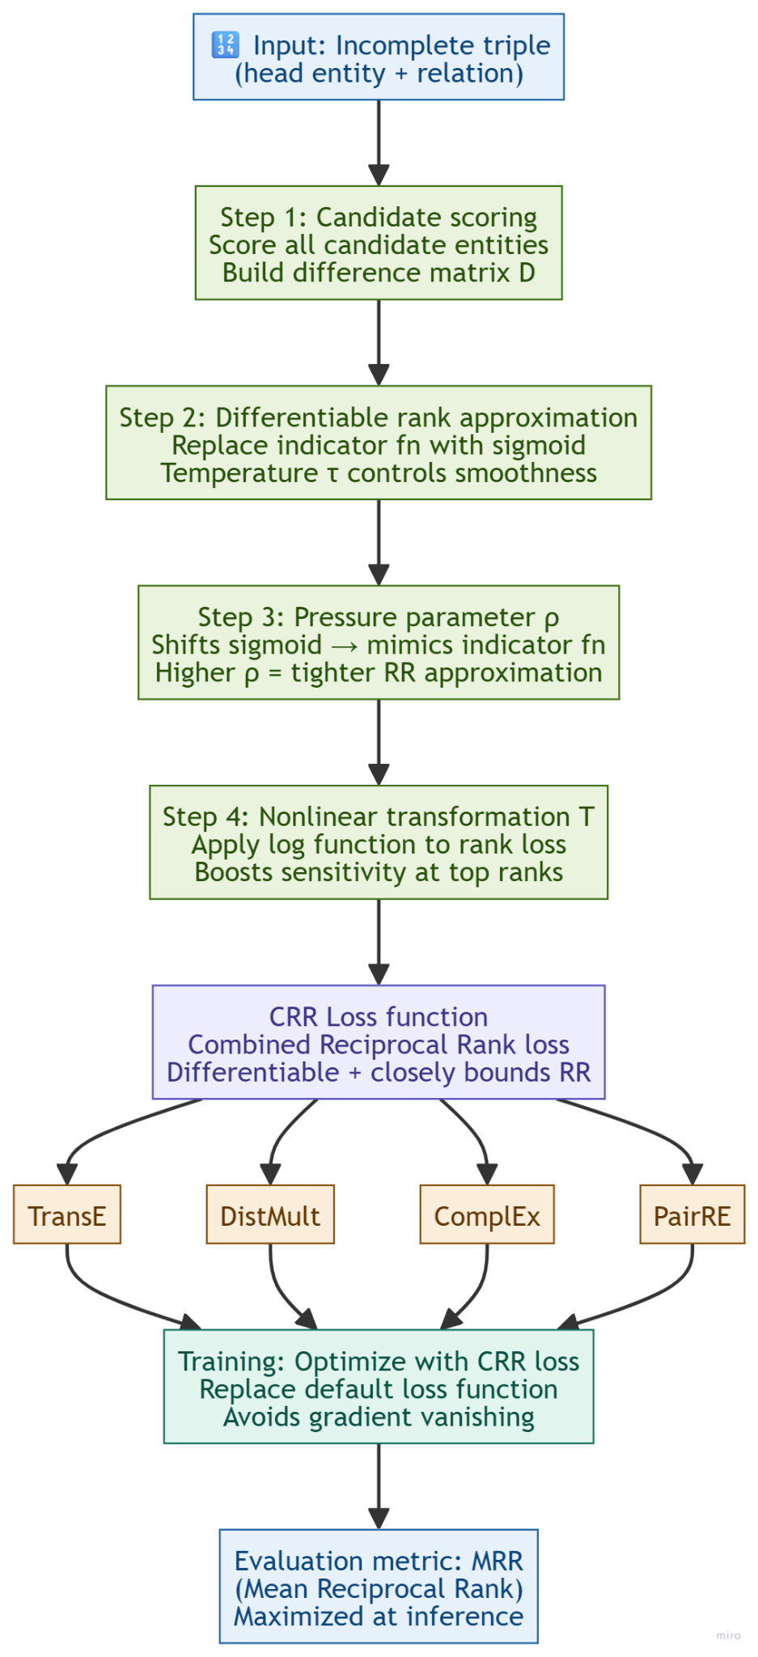

- CBLiP
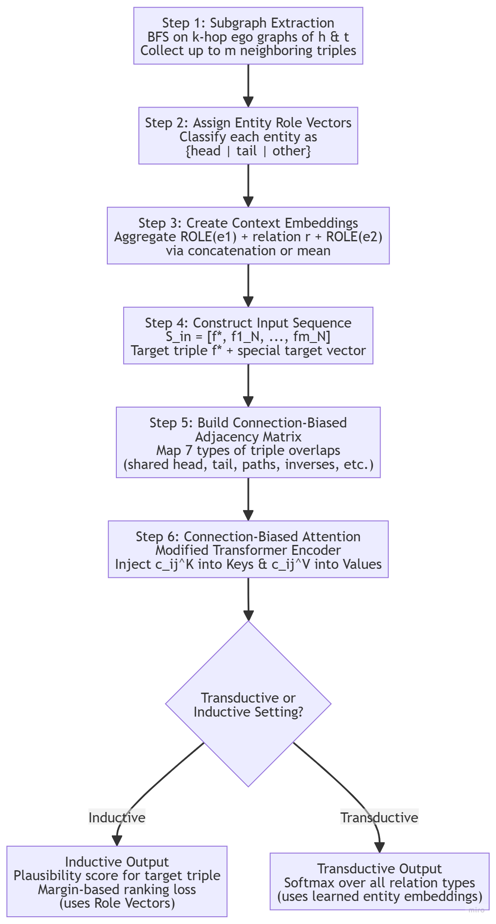
- RAA-KGC
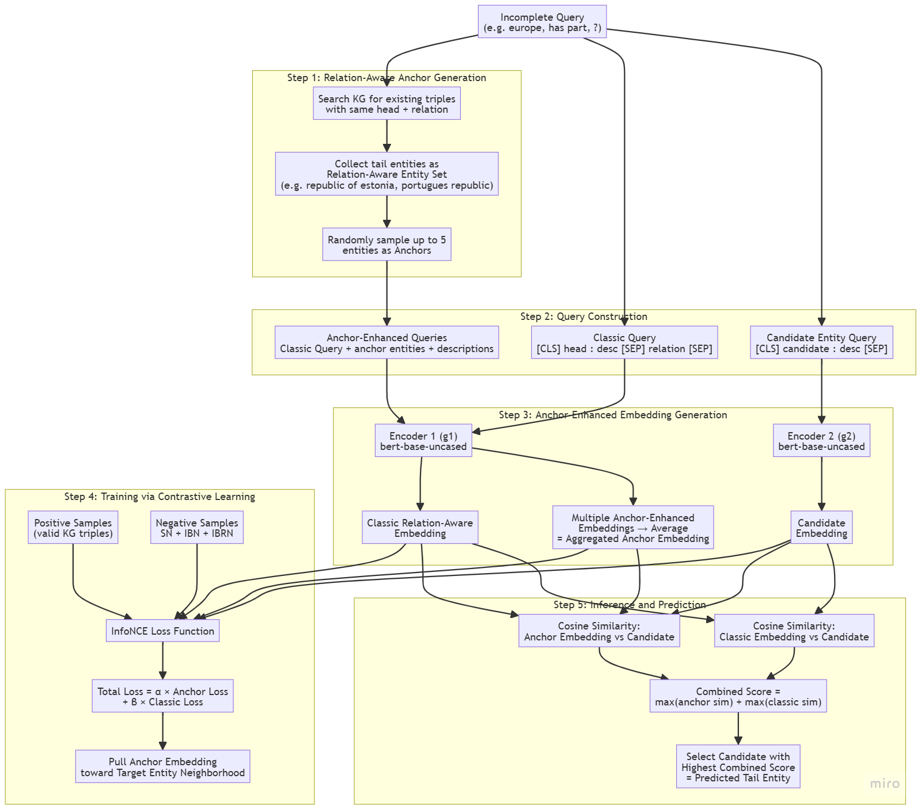

- SCFG
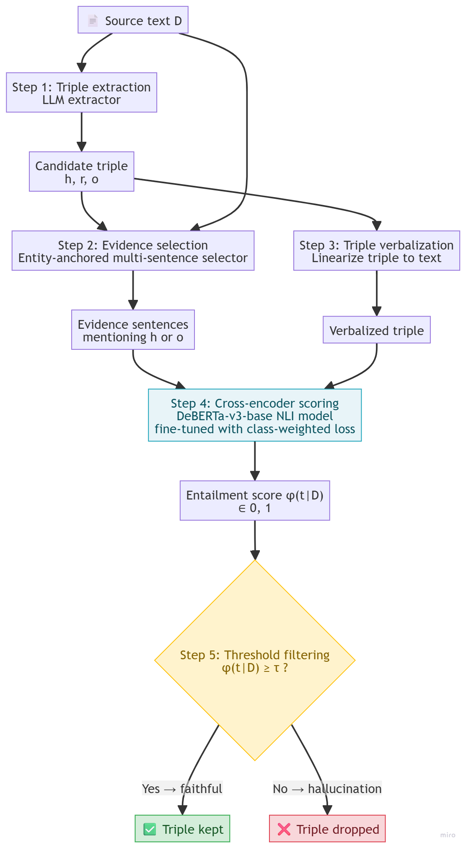

Meet extras -
- Multilingual Knowledge graphs
  - Research papers already on
    - Embedding alignment - align language specific KG embeddings via cross lingual seeds or entity alignment
    - PLM based unified semantic space - use multilingual BERT/XLM-R to consolidate multilingual knowledge
    - LLM based MKGC - existing MKGC research underutilizes the multilingual capabilities of LLM, ignores the shareability of cross lingual knowledge
  - Privacy - FedMKGC addresses federated/privacy preserving multilingual KGC
  - Idea 1 -
    - Multilingual + Inductive
    - What happens when a brand new entity appears at test time in a language it was never trained on
    - Multilingual handles multiple languages and inductive hands brand new unseen entities
  - Idea 2 -
    - CRR loss has never been tested in any multilingual setting
    - CRR loss proposed in KGCRR was tested only on FB15k-237 and WN18RR
    - Both of these datasets are english only
  - Idea 3 -
    - RAA anchors in cross lingual settings
    - Whether the system should purposefully favour high resource language neighbours as the “anchors” when dealing with low resource query
- Narrative
  - Two transductive tricks tested in the inductive and cross lingual setting, addressing the compounded challenge of entities that are both unseen at training time and described in a different language than training
  - 2 settings monolingual inductive and multilingual inductive, base (CBLiP) + CRR + RAA

19 June 2026
19 June 2026
- Research on Multilingual Knowledge Graphs
  - There are 3 papers
    - ALIGNKGC
      - Improved KGC by simultaneously aligning entities and relations across multiple languages
      - Information missing in one language maybe be available in another
      - Identify equivalent relationship through subject object signature approach
      - Reduces ID proliferation and enhances predictive accuracy
      - Evaluation on DBpedia dataset across 5 different languages
      - Entity alignment and Relation Alignment provides mutual benefits
      - Jist - the system bridges linguistic gaps to create more comprehensive and unified multilingual knowledge bases
    - MKGC
      - Novel framework for MKGC on how LLM identify missing information across different languages
      - Architectural mismatch - lead to knowledge overload and fragmentation
      - Paradigm discrepancy between text generation and entity ranking
      - KHGMoE (knowledge level grouped mixture of experts)
      - Cross lingual data and Iterative entity reranking (IER)
      - 5 languages - English, French, Italian, Japanese, Chinese
      - Outperformed SOTA
      - Leverages internal knowledge sharing even dealing with unbalanced data or languages not seen during specific training phases
      - Enhances completeness and accuracy
    - SSAGA
      - Other methods struggle with knowledge inconsistency and scarcity of seed alignment between languages
      - Treat language alignment as a unique edge type within a unified graph
      - Relation aware attention mechanism to adaptively control information flow
      - Self supervised generator which identifies new alignment pairs by recovering masked data
      - DBPedia dataset and newly created industrial E commerce knowledge graph
      - Dynamic knowledge transfer significantly improves accuracy

20 June 2026
20 June 2026

21 June 2026
21 June 2026

Meet Discussion
- Architecture of all the MKGC via Efficient knowledge sharing (Try to recreate)
- RAAKGC - Instead of BERT, use new and latest embeddings
- Decide Skeleton entire architecture
- Later - Multimodality (Brainstrom)
- Bilingual sentences (Hinglish) (Aryan nei laal coat pehna hai) (Brainstrom)

22 June 2026
22 June 2026

23 June 2026
23 June 2026
Multilingual Knowledge Graph Completion Via Efficient Multilingual Knowledge Sharing
- Components
  - KL-GMoE (Knowledge level Grouped Mixture of Experts)
  - IER (Iterative Entity Reranking)
- Base LLM
  - Llama 2 7b chat hf
    - Fine tuned with LoRA (rank 4)
- Problem
  - LLM’s own multilingual ability
  - Shareability across languages (A fact missing in one language may exist in other)
  - Knowledge overload vs Knowledge fragmentation
    - Single shared adapter gets overloaded trying to hold all language relations together
    - Fully separate per language adapter fragment knowledge and lose what is shareable
  - Paradigm discrepancy
    - Vanilla LLM KGC generates a tail entity
    - KGC is evaluated as ranking
    - Single generated answer gives Hits@1
    - IER closes this gap by turning LLM’s pick into a ranked list
- Pipeline
  - Two stage retrieve then rerank system
  - KGE candidate retrieval
    - KGE model (TransE) scores all entities for the query q=(h,r,?)
    - Returns top-m candidates Mc=[e_1, …, e_m]
  - LLM reranking
    - Fine-tuned LLM (with KL-GMoE) selects the best candidate
    - IER then iterated selection into ranking
  - Prompt Construction P(q)
    - q=(h,r,?)
    - Q = query (h,r,?)
    - D = Textual description of head entity h
    - N = neighbour facts, triples containing h, samples from KGE training data
    - Mc = Candidate entities [e_1, …, e_m] from KGE top-m
    - LLM is asked to select(rank)
    - e_hat=argmax_{e_i in Mc} P(e_i | h, r, Mc)
    - Prompt examples are drawn from a validation subset and not KGE’s own training data
- KL-GMoE
  - Asymmetric LoRA MoE inserted into LLM’s FFN layers
  - Built on HydraLoRA idea (one shared down-projection A, many up-projections B as experts)
  - Generalized to groups
  - Grouped expert structure
    - Ng groups
    - Group i showed one shared A-matrix A_i plus a set of B-matrices {b_{i,j} : j = 1..Nb}
    - Expert is a pair E_{i,j} = (A_i, B_{i,j})
    - Total experts = Ng x Nb
    - Intuition
      - A_i captures a similar knowledge category shared across the group and languages
      - Each B_{i,j} captures the subtle differences within that category
    - G_i = ( A_i , {B_{i,j} | j in 1..Nb } ), i in 1..Ng
  - Knowledge Level routing (three routes)
    - Routing is computed from (h,r,t) token representations x_m, m in {h,r,t}
    - Route 1
      - Group routing Rg picks which group (which shared A_i)
      - i* = argmax_i ( sum_{m in {h,r,t}} Softmax(Wg x_m) )
    - Route 2
      - Knowledge based routing Rk scores B-experts from raw tokens
      - S_k = sum_{m in {h,r,t}} Softmax(Wk x_m)
    - Route 3
      - Latent based routing Rl scores B experts from the down projected latent (uses the chosen group’s A_i)
      - A_l = sum_{m in {h,r,t}} Softmax(Wl (A_i* x_m))
    - Selected expert
      - Within chosen group combines both scores
      - j* = argmax_j ( S_k + S_l ) -> expert B_{i*,j*}
  - Integration into the FFN
    - KL-GMoE output is added as a residual on top of the frozen FFN output
    - Y_e = B_{i*,j*} ( A_{i*} X )
    - Y = W0 X + y_e
    - Only activated expert’s parameters are used per sample(sparse)
    - LoRA rank =4
    - Base weight W0 stay frozen
    - Only A_i, B_{i,j} and router matrices Wg, Wk, Wl train
    - Paper reports standard supervised fine tuning on the selection task, no explicit load balancing loss is described
- IER (Iterative Entity Reranking)
  - Single argmax only yields the top-1 entity
  - Cannot produce Hits@3, Hits@10, MRR
  - IER extracts top entity, removes it, repeates building a ranked prefix of length Nt
  - For t = 1 .. Nt (with Nt=10)
  - e(t) = argmax_{e_i in Mc(t)} P(e_i | h,r,Mc(t)) #LLM picks current best
  - Mc(t+1) = Mc(t) \ { e(t) } #remove it from candidates
  - L(t+1) = Insert( L(t) \ { e(t) }, t, e(t) ) # place it at rank t in the list
  - Insert(list, pos, e) removes e then re inserts it at position pos
  - After Nt rounds you have a fully ranked top-Nt
  - The remaining candidates keep their KGE order below
  - No early stopping, fixed Nt = 10
  - Training trick
    - The candidate list size m is randomized in [25,30] during training so the model learns to rank under varying list lengths
- Data, metrics, results
  - Dataset - Wikidata5M extended to 5 languages

 | EN | FR | IT | JA | ZH
Train triples | 708267 | 839623 | 613014 | 321237 | 546626
  - Total
    - Entities - 351299
    - Relations - 2264
    - Triples - 3028767
  - Headline result
    - H@1 = 41.88
    - H@3 = 50.93
    - H@10 = 58.78
    - MRR = 47.86
    - Prior SOTA GC-PLM
      - +5.47 H@1
      - +3.27 H@3
      - +1.01 H@10
      - +6.13 MRR
  - Training
    - LR = 2e-5
    - LoRA rank 4
    - Candidate length 25-30
    - IER iterations 10
- Flowchart

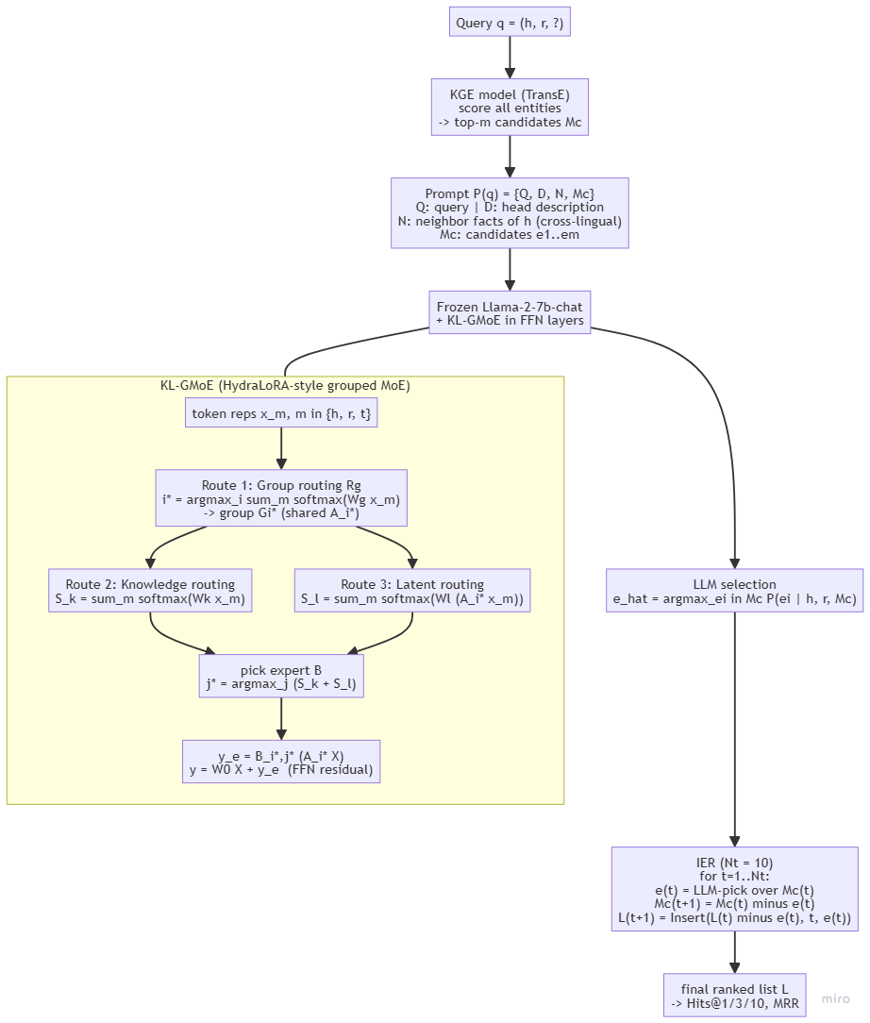
- How this inserts into our direction (Multilingual + Inductive)
  - Our planned system - CBLiP base + CRR loss + RAA anchors in monolingual inductive and multilingual inductive settings
  - KL-GMoE is a fine tuning adapter, base model agnostic in spirit
    - Targets FFN layers of a decoder LLM
    - Our base is CBLiP (A transformer encoder over subgraphs)
    - KL-GMoE would need re targeting to CBLiP’s attention
    - FFN blocks if we want cross lingual parameter sharing
  - IER is purely reranking wrapper over any model that can score candidates
    - Composes cleanly with CRR
    - CRR optimizes the ranking objective during training
    - IER restructures the ranked list at inference
  - Inductive Gap
    - Transductive (entities are seen, KGE embedded)
    - KGE retrieval stage assumes learned entity embeddings, which break for unseen entities
    - For our inductive setting we will replace KGE retriever with CBLiP’s inductive setting (subgraph + entity role) and keep IER on top
    - “Transductive trick in an inductive setting”
  - Cross lingual sharing happens at 2 levels
    - Data level (neighbour facts N pulled across languages)
    - Parameter level (shared A_i)

RAA-KGC Encoder Modernization
- Decision
  - Replace RAA-KGC’s bert-base-uncased encoders with BGE-M3 as the primary
- Task
  - RAA-KGC
    - Two unshared encoder + InfoNCE + In batch Negatives Bi encoder
    - SimKGC lineage of text based KGC
    - Consequences
      - Natively Inductive
        - Entity is represented by encoding its description
        - Not be memorized embedding row
        - Unseen entities are handled by construction
        - SimKGC reaches MRR 71.4 on Wikidata5M-Ind which is impossible for TransE style transductive models
        - Makes RAA-KGC second inductive backbone alongside CBLiP
      - Bert-base-uncased
        - English only
        - Multilingual + inductive system cannot run on it
  - BGE-M3 is built on XLM-RoBERTa, the multilingual sibling of BERT
- Decision

Role | Model | Rationale
Primary (Main Model) | BGE-M3 | 100+ langs, retrieval trained, strong cross lingual alignment, 8K ctx, fine tunes on 16GB with a usable batch. Best balance of multilingual + cross lingual + trainable
Light baseline | multilingual-E5-base | Smaller->Bigger batch->more in batch negatives
Modern contender | Qwen3-Embedding-0.6B | Newest LLM based, instruction aware, benchmarks the BGE-M3 choice against the 2025/26 SOTA family
Cross lingual probe | LaBSE | Weaker general retrieval but trained explicitly on translation pair alignment

